Steiner Points in the Space of Genome Rearrangements
David Sankoff, Gopalakrishnan Sundaram, John Kececioglu
International Journal of Foundations of Computer Science, Vol. 7, No. 1, Pp.1- 9, Mar. 1996
Abstract
This paper explores the concept of multiple genome comparison, analogous to multiple sequence alignment in sequence comparison. We first describe a heuristic for the case in which phylogeny is a star on three vertices and then use this to approximate the multiple genome comparison problem via local search.
- Introduction
- The notation of the genome rearrangement
- The Steiner problem
2. The phylogenetic versions of the Steiner problem
I. given: fixed phylogeny(tree), and a set of permutations (genome) each of size corresponding to the terminal nodes.
II. find: a set of permutations corresponding to the internal nodes
such that 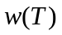 is minimized.
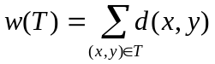 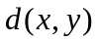: the genome rearrangement distance
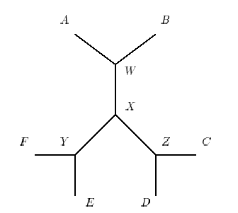
- A heuristic for the median problem
- Consider a special case of multiple genome comparison where the phylogeny is a star on three vertices, this is the median problem.
- Definition of the median problem
- The heuristic algorithm
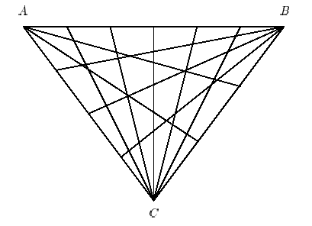
- A heuristic for the original problem
- Assume that the given phylogeny is an unrooted tree.
Decompose it into 3-stars corresponding to the internal nodes.
Iteratively improve the stars on three vertices, by the heuristic for median.

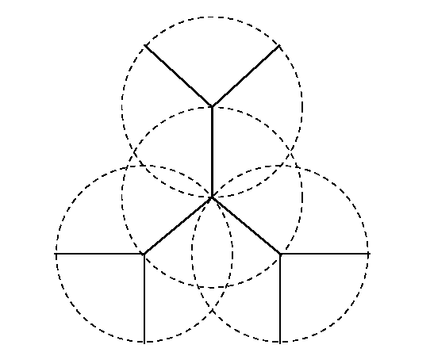

Created by: Hung – Wei Huang
Date: Jan. 27, 2003
- The genome rearrangement
  - Permutation () : an ordered arrangement of
the set { 1,2,…,n}, we assume that the order of genes in a genome is represented by a permutation 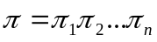.

I. Inversion

II. transposition

  - Given and , we find a series of operator 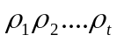 such that 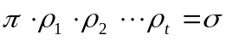, t is the rearrangement distance between and .

- The Steiner problem
  - input: a set of n points in the place
output: the shortest tree whose vertices contain the n points
example:
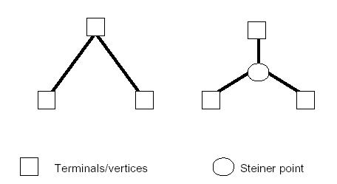

  - The problem is NP-complete

